

**Instabase, Inc**

220 Montgomery St. Suite 344

San Francisco, CA 94104

**Instabase Student Guide**

**October 22, 2017**

# OVERVIEW

All of the course modules that include hands-on work with SQL, Python, or the R programming language use Jupyter notebooks. To avoid each student needing to install Jupyter on his or her computer, Instabase provides Jupyter notebooks hosted in the cloud.

The instructions in this document should be sufficient to get you started.

# GETTING STARTED

## Step 1: Get an Instabase account

1. Go to <https://www.instabase.com/account/register?use_token=true>
2. Type in your email and your desired username and password.
3. Use the token: **<your instructor will give you a token>**
4. Click the Create an account button, complete the email verification process, and you’re all set.

**Note:​** If you tried to get an Instabase account without following the link above and were placed on a waiting list, please follow this link [<https://www.instabase.com/account/login?use_token=true>] to activate your account using the same token as in Step 3.

## Step 2: Manage and Explore Repositories

Repositories in Instabase contain your data, notebooks, and other files. They are organized with  
folders and files, just like a typical filesystem. Once your account is created and you log in, you  
will see an initial repository named my-repo. You can change the repository name by clicking the three vertical dots at the right end of the repository name and selecting **Settings** from the dropdown menu.

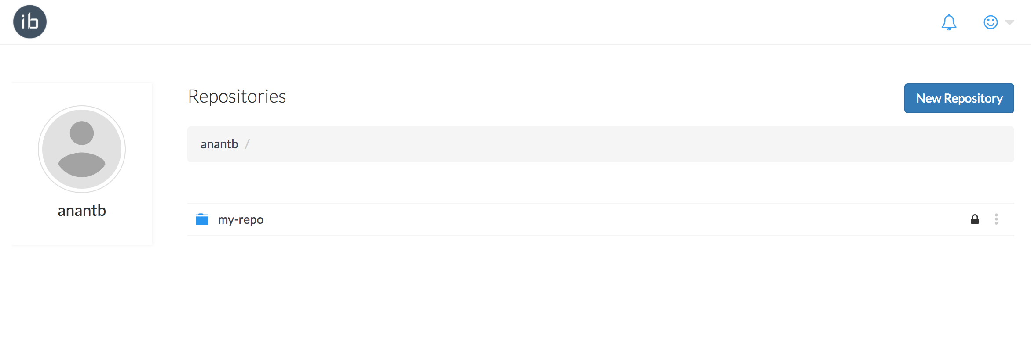

Figure 1: The home page shows all your repositories.

Click on the automatically-created repository (the one originally called my-repo) and explore the contents.

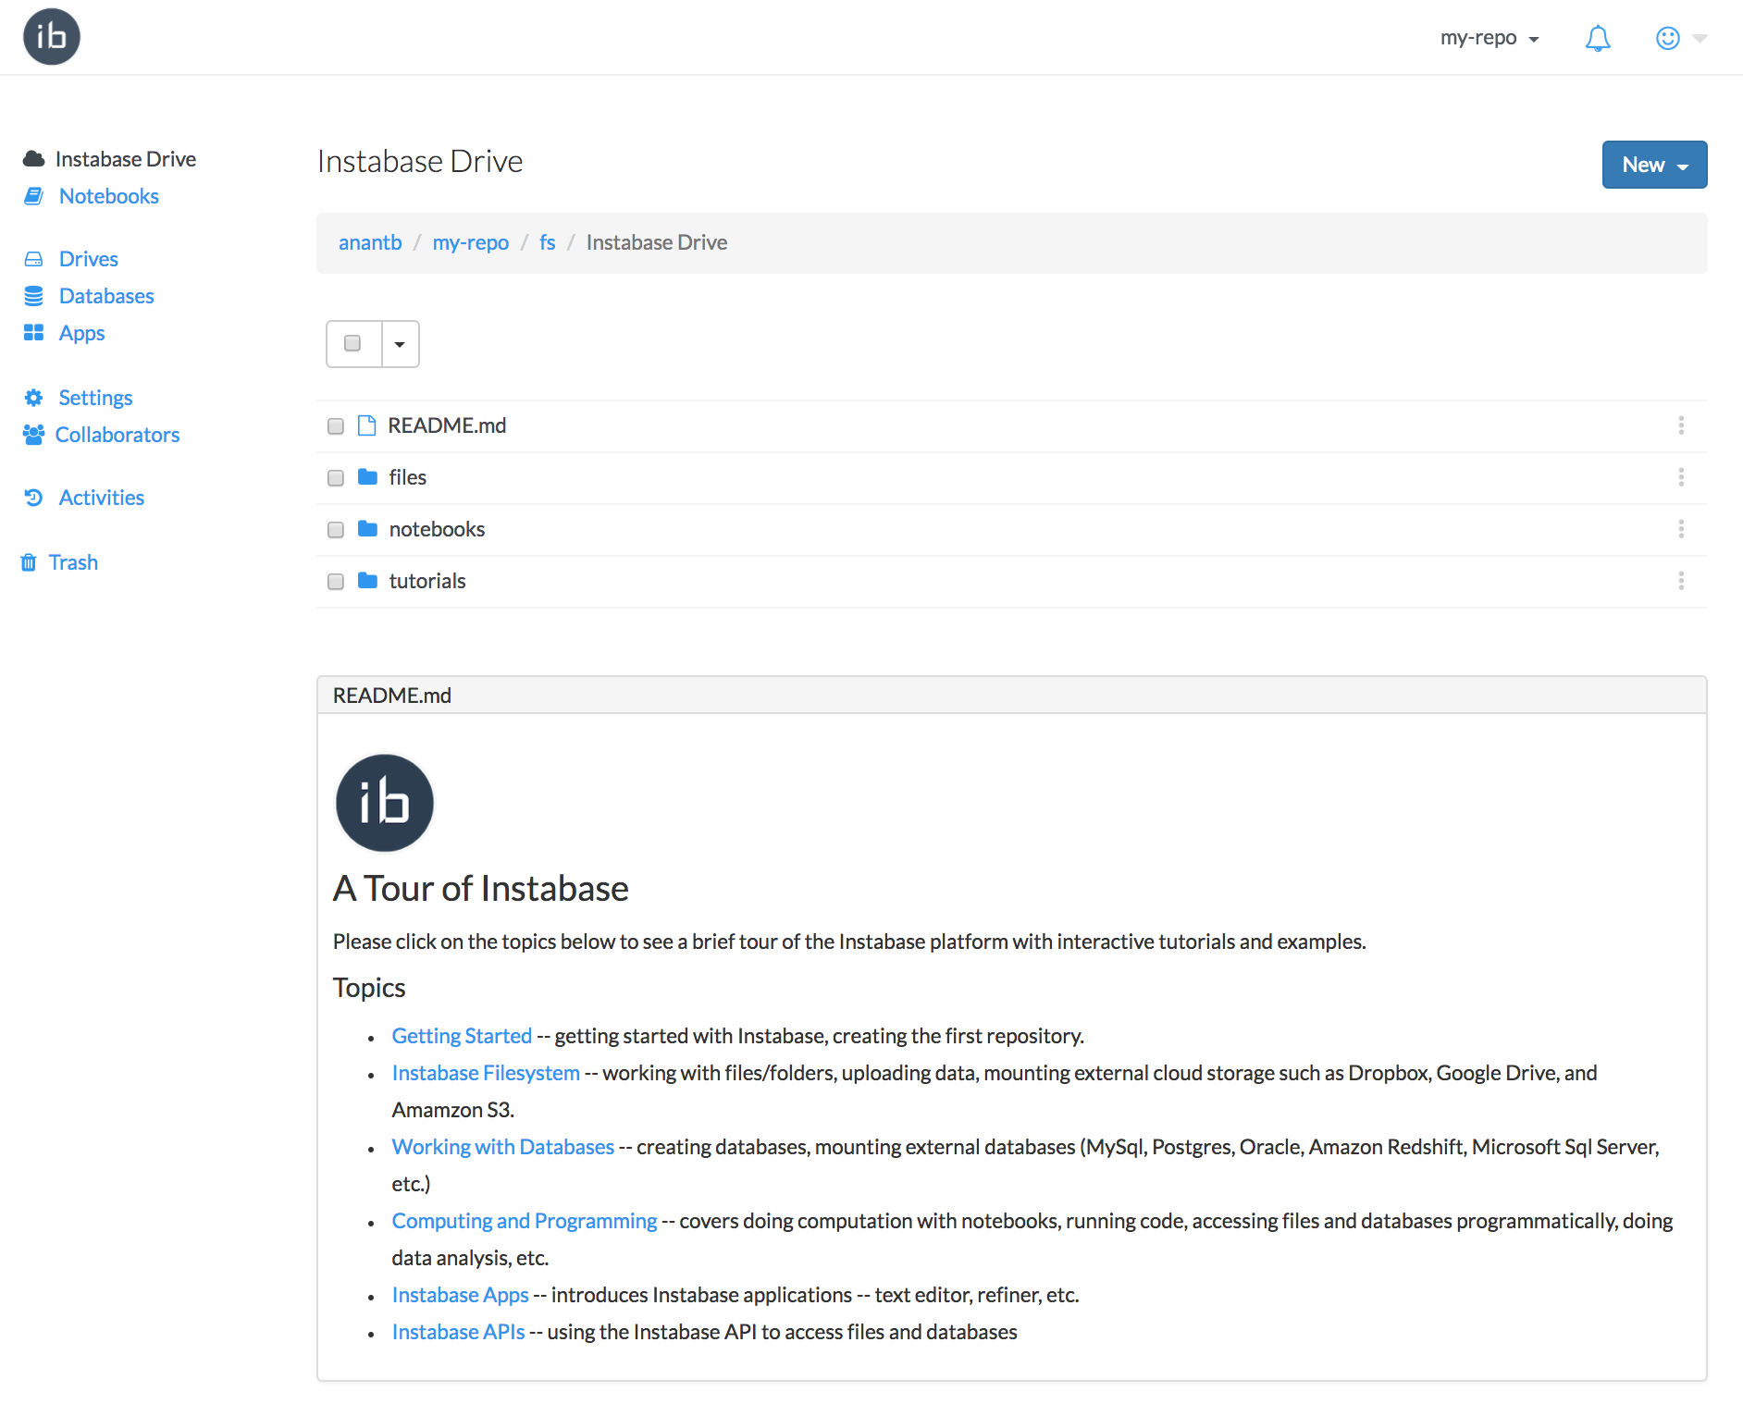  
Figure 2: The inside view of a repository: they contain your data, notebooks, and other files.

File README.md is displayed automatically with the heading A Tour of Instabase​. The links go to help and other files stored in the tutorials folder. Two other folders: files and notebooks, are also present in the repository but are empty -- these two folders are added automatically whenever a new repository is created.

## Step 3: Copy Course Materials

The following links contain the course materials: copy them inside your repository.

* Relational Databases and Basic SQL: <https://www.instabase.com/widom/SQL>
* Advanced SQL: <https://www.instabase.com/widom/Advanced-SQL>
* Python for Data Analysis and Visualization: <https://www.instabase.com/widom/Python>
* Data Mining Using SQL: <https://www.instabase.com/widom/Mining-SQL>
* Data Mining Using Python: <https://www.instabase.com/widom/Mining-Python>
* Using Python for Machine Learning: <https://www.instabase.com/widom/ML-Python>
* The R Language: <https://www.instabase.com/widom/R-Language>
* Using R for Machine Learning: <https://www.instabase.com/widom/ML-R>

Follow the link for your course module. You will see a listing of the notebook and data files you will need for your module. Click on the drop-down menu above the folder listing, choose **Select All**, then click on the **Copy** link that appears:

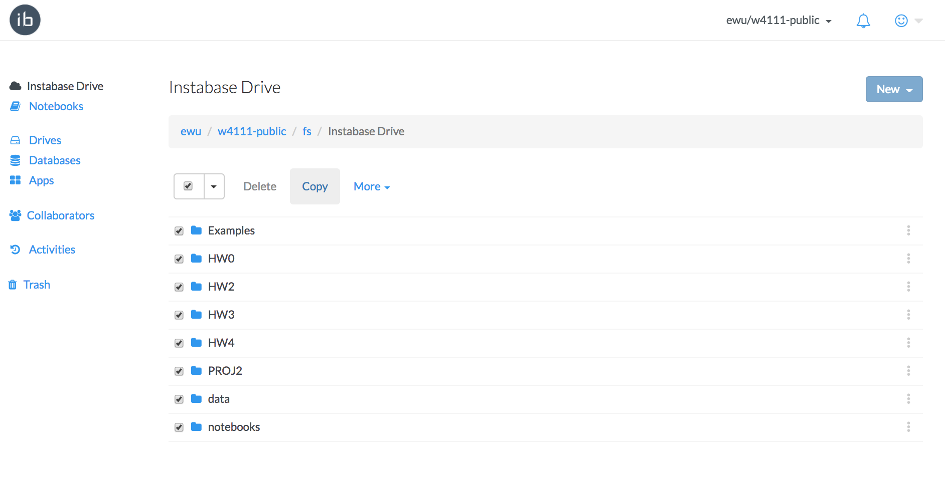

Figure 3: You can copy the public course materials by selecting the folders and copying them inside your repository.

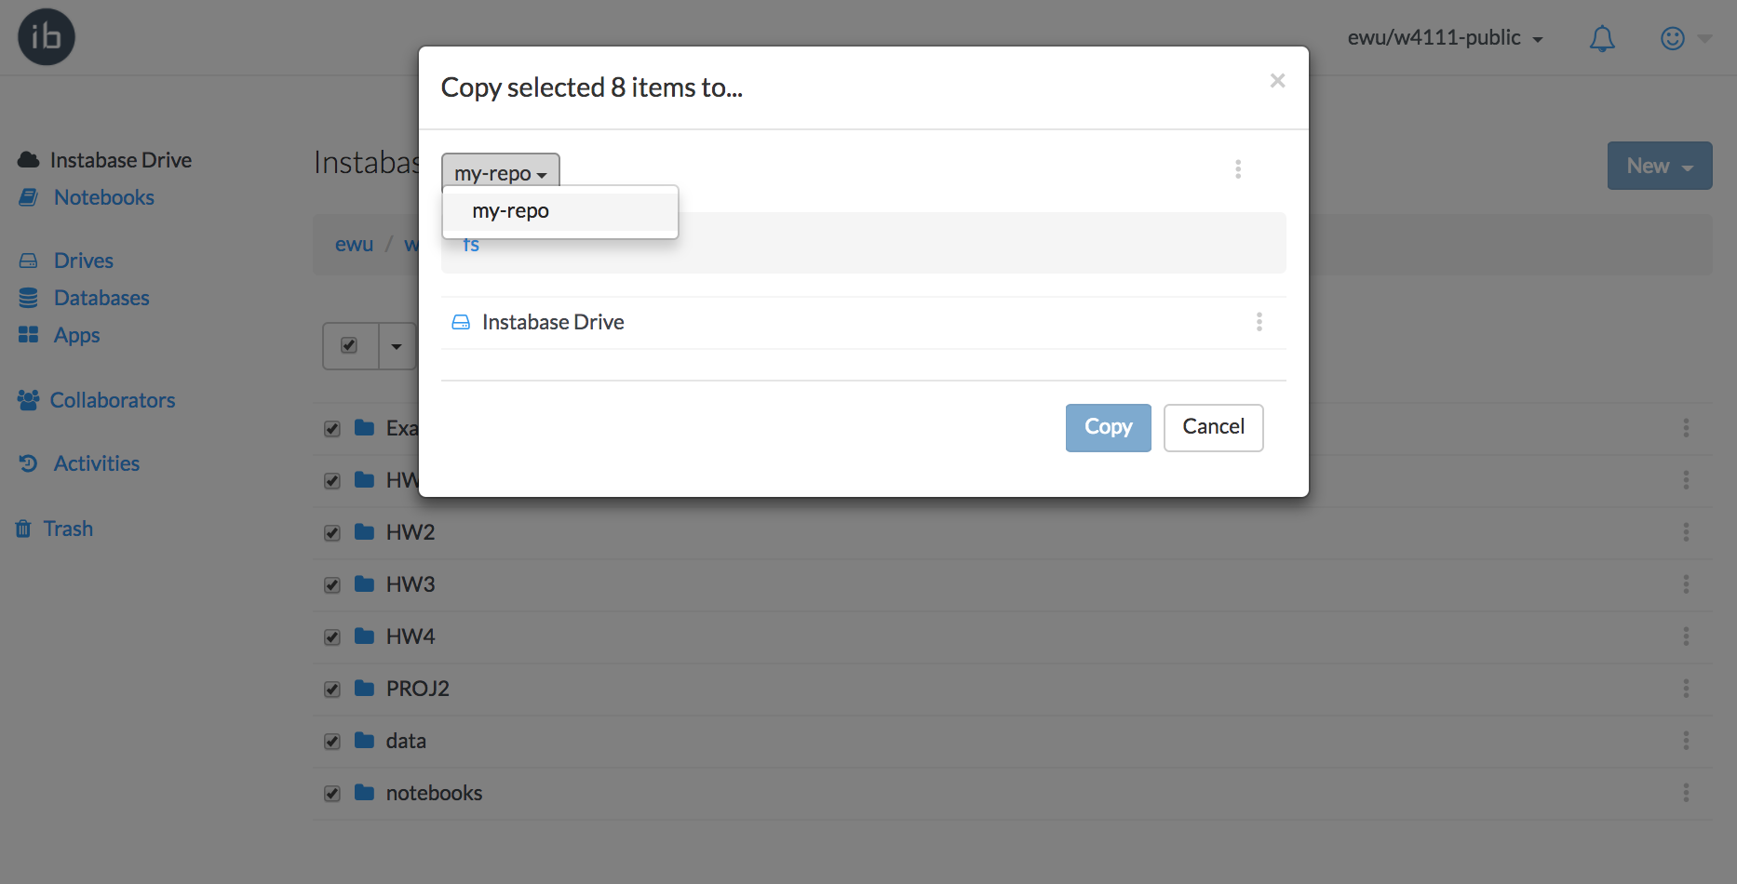

Figure 4: In the copy prompt, you can select your repository (for example: my-repo) to copy the materials inside your repository. Make sure to select Instabase Drive before you click Copy.

## Step 4: Open Notebook for Your Course Module

Right-click or control-click on the notebook you would like to open and select **Open With > Jupyter**. Sometimes it will take a minute or so for a new Jupyter server to start up on your behalf. Once it does, you are ready to go!

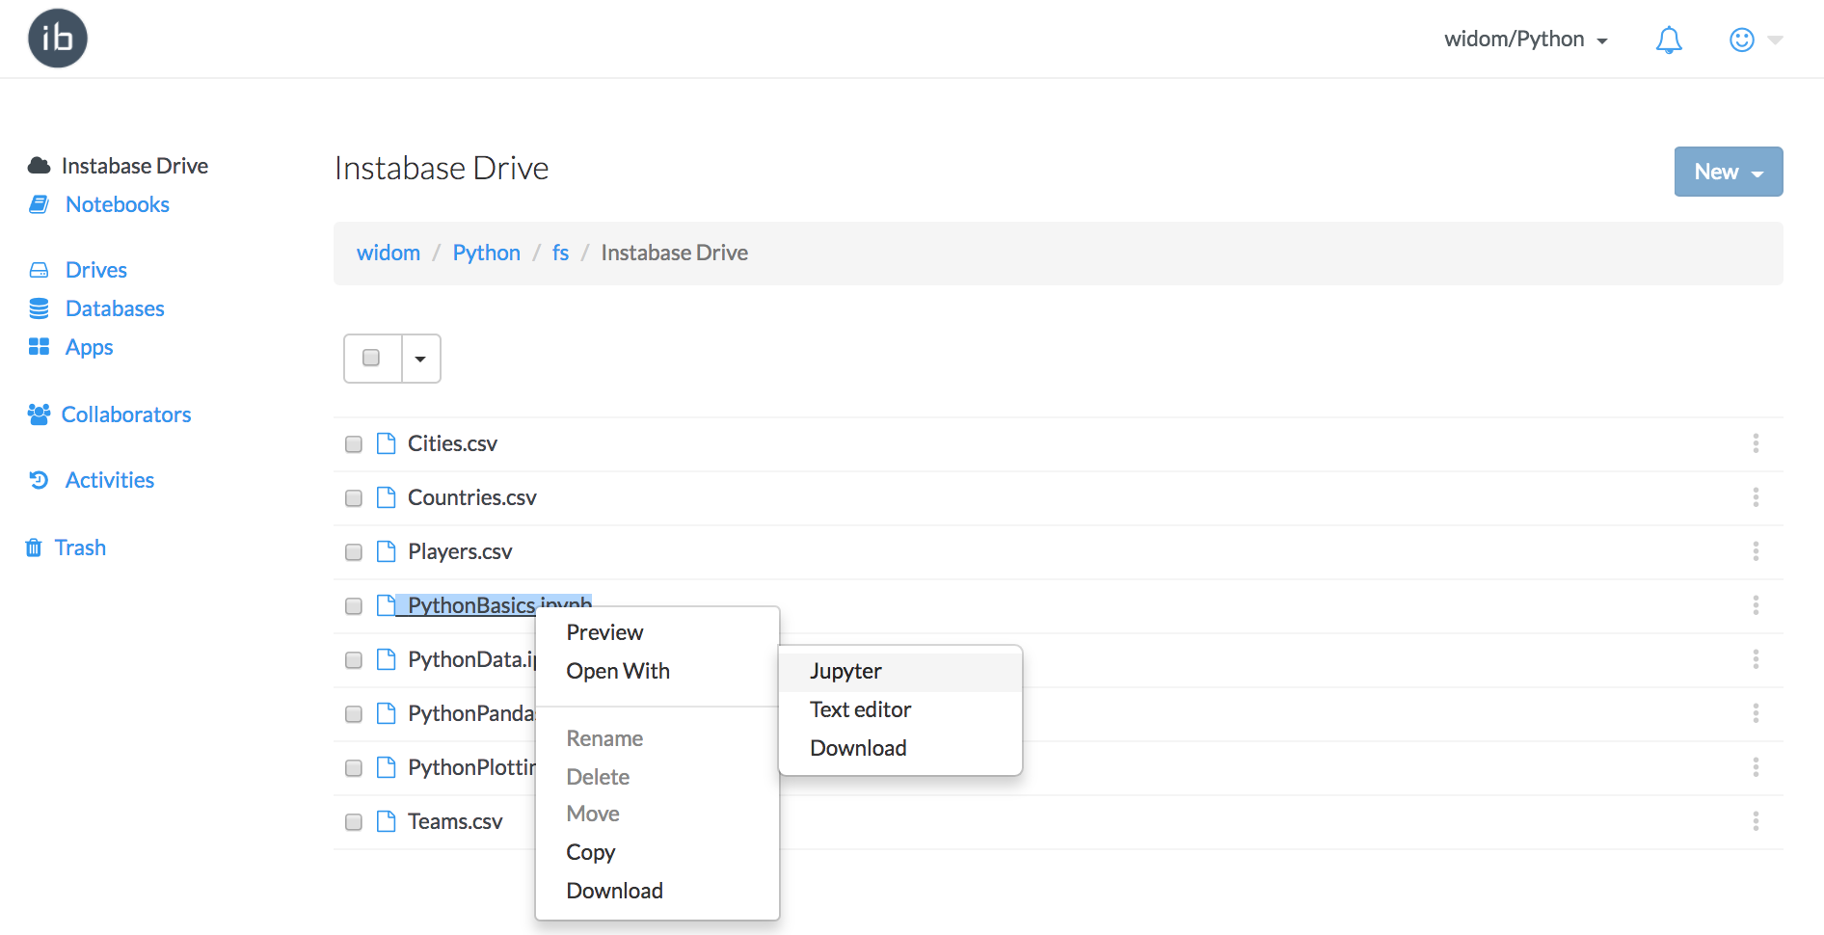

Figure 5: Open the notebook for the course: you are ready to go!

# USEFUL LINKS

* **Instabase Getting Started Guide:** <https://drive.google.com/open?id=1la9nqPu5k_WixDstHpt4RRmC7sRaloRa6MVB7KSu5DE>
* **Notebook Common Errors and Cheatsheet:** <https://drive.google.com/open?id=1WmIVn8GH76R_D7UpsQQwE3UVics4I5pwP28Xgg318MM>